FR 2 Devoirs 3.3.2 Nom __________________________________

A. MangerBouger. Answer the following questions about this MangerBouger advertisement
in complete sentences.

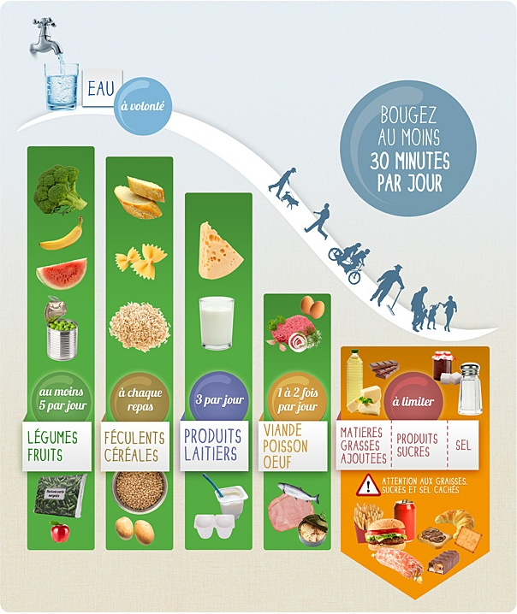

1. Qu’est-ce MangerBouger prescrit pour l’eau?
______________________________________________________________________________________

2. Il faut bouger combien par jour?
______________________________________________________________________________________

3. Qu’est-ce qu’il faut manger 3 fois par jour?
______________________________________________________________________________________
4. Il faut manger combien de légumes et fruits?
______________________________________________________________________________________

5. Quels sont les féculents?
_____________________________________________________________________________________

6. Qu’est-ce qu’il faut manger 1 à 2 fois par jour?
______________________________________________________________________________________

7. Qu’est-ce qu’il faut limiter?
______________________________________________________________________________________

8. Il faut faire attention à quoi?
______________________________________________________________________________________

B. MangerBouger. Based on the MangerBouger commercials you saw, describe in French
what changes you could make in your life to meet MangerBouger
guidelines.

________________________________________________________________________________________________________________________________________________________________________________________________________________________________________________________________________________________________________________________________________________________________________
________________________________________________________________________________________________________________________________________________________________________________________________________________________________________________________________________________________________________________________________________________________________________
________________________________________________________________________________________________________________________________________________________________________________________________________________________________________________________________________________________________________________________________________________________________________

